FlexChroma™ Blend Filament Guide
目次
1. Introduction 1
Brand Overview 1
Series Overview 1
2. Model Structure 2
Mixing Ratios 2
Sizes 2
3. Mixing Results 3
Small brightness difference (CMY) 3
Large brightness difference (White / Black) 3
Differences by Material 4
4. Filaments to Prepare 4
5. Printing instructions 5
Printing Workflow 5
Before Print #1 (Blend Filament) 5
Before Print #2 (Final Print) 6
6.Closing 6

1. Introduction
FlexChroma™ Blend Filament is a model designed to create intermediate colors by combining two commercially available filaments.
By using this model, you can obtain 29 different colors, including the original two filaments.

Brand Overview
FlexChroma is a brand created not only for people who are unsatisfied with the color options of existing filaments, but also for those whose limited filament collection prevents them from fully expressing their creativity.
Its goal is to expand your freedom in color selection.
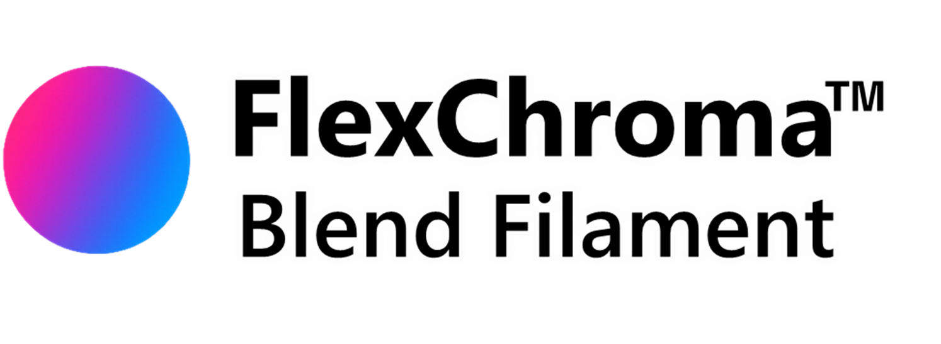

Series Overview
The Blend Filament series is the core of FlexChroma. By mixing two filaments in 5% steps, you can create your own new color. For finer control—or for combinations with large brightness differences—Detail Models are available. These cover 95–99% mixing ratios in 1% increments, enabling adjustments beyond what Standard Models can achieve.

2. Model Structure
This series is divided by size, and each size includes both Standard Models and separate Detail Models.

Mixing Ratios
Mixing ratios are mainly defined by two model types:
- Standard Model: 50–95% in 5% increments (10 models)
- Detail Model: 90–99.5% (9 models)
※ The 90%, 95% model is identical in both series.
Although there are 17 mixing ratios, excluding 50%, you can reverse filaments A and B to obtain the opposite ratio.
(Example: Using the 75% model gives A:B = 75:25; reversing filaments results in A:B = 25:75, equivalent to the 25% ratio.)
Standard Models may be split into Standard 1 and Standard 2 to reduce file size.

Sizes
Models starting with "M" are sized to print on Bambu Lab P-series and A1 printers.
Models M1-M4 are sized to fit on major 3D printers other than Bambu Lab.
Models S1-S4 are sized to print on Bambu Lab A1mini.
Models starting with "L" are larger models that can be handled by Bambu Lab H-series printers. This may be implemented in the future.

You won't know what color your mixed filaments will actually produce until you print them. The Blend Color Checker allows you to check the color of each mixed ratio at once.

3. Mixing Results
Some filaments show stronger color presence when layered, while others do not.
Filaments with lower brightness tend to show stronger color influence, while filaments with higher brightness tend to show weaker influence.
Because of this, choosing the appropriate model depends on the filament combination.
Characteristics of Mixing

Small brightness difference (CMY)
Combinations such as Cyan, Magenta, and Yellow have small brightness differences and result in final colors that correspond relatively linearly to the mixing ratio.
In this case, Standard Models alone will give sufficient results.
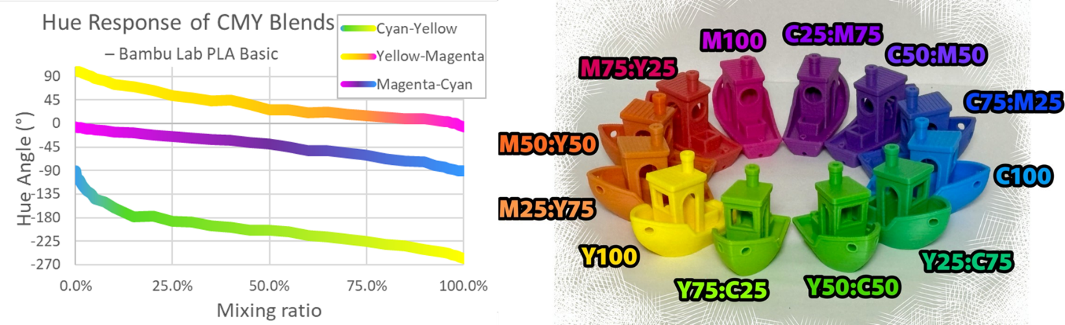

Large brightness difference (White / Black)
Combinations with a large brightness difference, such as black and white, are strongly influenced by the darker filament.
As a result, the expressive range becomes limited when using only Standard Models.
In such cases, please use the Detail Models.
The filament being printed has high viscosity and does not mix sufficiently inside the nozzle.
Therefore, printed results using blended filament may appear mottled.
This is not noticeable when brightness contrast is small, but becomes apparent when the contrast is large.
To create light gray using Blend Filament, it is recommended to use white + gray rather than white + black.
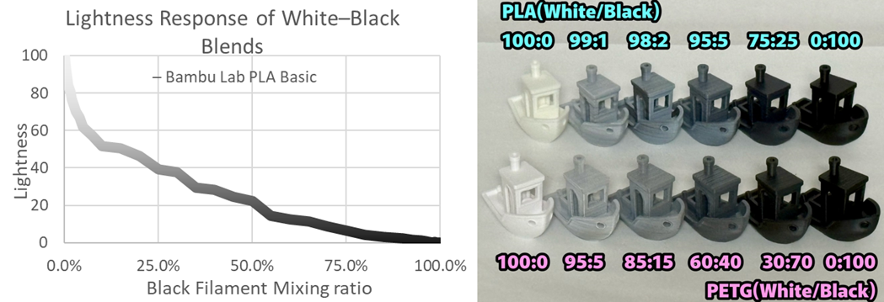

Differences by Material
Looking at the black-and-white results:
- PLA and PETG produce different blending results.
- PLA Basic white is highly translucent, so its influence becomes extremely weak.
- PETG HT white has lower translucency, so its influence becomes stronger compared to PLA Basic.
Blending is affected not only by the base color but also by translucency.
Test printing is recommended.

4. Filaments to Prepare
The recommended set is Bambu Lab PLA Basic in Cyan, Magenta, Yellow, and White.
With these four colors, you can cover most of the fundamental color mixing needs.
Black can also be useful for extending the color range, but its influence is very strong and tends to create uneven or muddy results, so it should be used with caution.

In theory, the midpoint between two primary colors is defined in a uniform color space (such as LCh) as the “perceptual midpoint color.”
However, when actual filaments are mixed, the resulting “material-mixing midpoint” often loses saturation and deviates from the ideal midpoint due to the absorption spectra of the pigments and the subtractive-mixing nature of filament materials.
For this reason, to reliably provide the hue and chroma that users typically expect as a natural intermediate color, we introduce “recommended bridge filaments,” as illustrated in the diagram.

Cyan, Magenta, and Yellow are not evenly spaced on the hue circle.
The Cyan–Yellow interval is the widest, followed by the Yellow–Magenta interval.
Because of this uneven spacing, the midpoints produced by mixing these pairs tend to show reduced saturation or do not appear as the intuitive intermediate color users expect.
Therefore, we recommend using:
- Bamboo Green as a bridge color between Cyan and Yellow, and
- Orange as a bridge color between Yellow and Magenta.
On the other hand, the Cyan–Magenta interval is the narrowest, and the material-mixing midpoint naturally falls closer to where the true midpoint should be compared with other axes.
For this reason, we do not introduce a recommended bridge filament for the Cyan–Magenta pair.
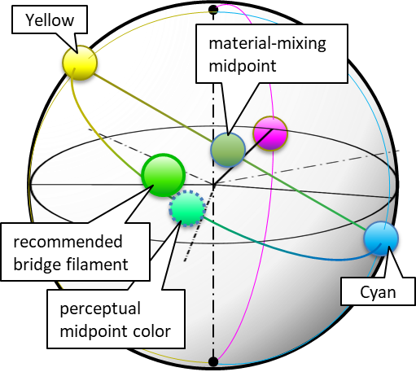

5. Printing instructions

Printing Workflow
This model is used to create blended filament.
- Using two commercially available filaments, print Blend Filament (Print #1).
- Using this blended filament, print the model you want to create (Print #2).
With this two-step printing process, you can produce any shape in the color you want.
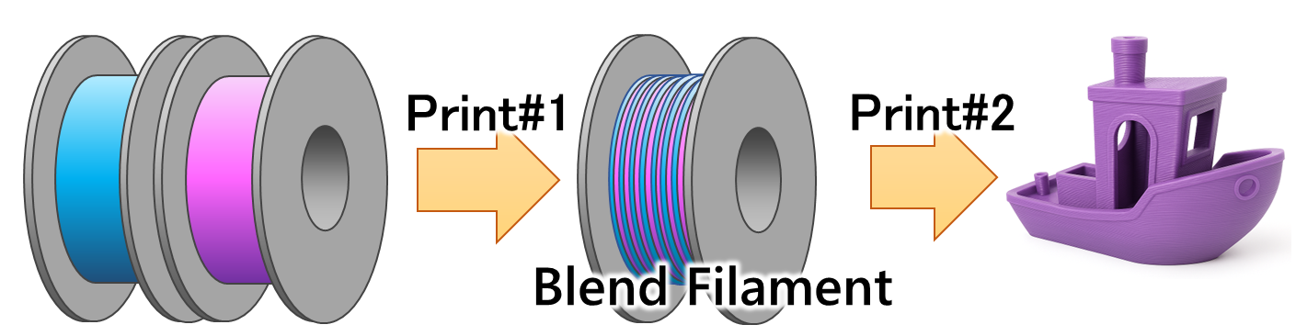

Before Print #1 (Blend Filament)
Required
- AMS required
Frequent switching between two colors is necessary.
Use a printer that supports switching between two or more filaments.
- 0.4 mm nozzle required
A 0.4 mm nozzle is essential due to the combination of a relatively thick first layer and thin layers for maintaining mixing accuracy.
0.4 mm high-flow nozzles are acceptable.
- Degrease the plate and your hands
This model is very sensitive to adhesion.
Ensure thorough cleaning.
If adhesion remains difficult, consider using a smaller model size.
Recommended
- Textured PEI plate
The model is tuned specifically for textured PEI plates.
Other plates may produce slightly lower Z-height and are not recommended.
- PLA
This model requires good adhesion. PLA should print without issues, but other materials may not.
Adhesion difficulty increases in the order: PLA → ABS → PETG.
Not Recommended
- Glue
Glue may clog the nozzle during Print #2.
- Mixing different material types
Filaments with different printing temperatures may clog the nozzle during Print #2.
Combinations such as PLA Basic and PLA Matte (same temperature and same material type) may work.
As a general rule, use different colors of the same product from the same manufacturer.
Try other combinations at your own risk.

Before Print #2 (Final Print)
- Remove the brim
Remove the brim before printing.
If you will not print immediately, leave the brim attached.
The engraved markings allow you to check the size and mixing ratio.
- Remove burrs
Rarely, burrs may occur.
Remove them with nippers or a cutter.
Large burrs may cause extrusion issues.
- Nozzle influence in Print #2
The ease of mixing varies depending on the type of nozzle. High-flow nozzles tend to mix more easily than standard nozzles.

6.Closing
Thank you for reading.
We hope that FlexChroma™ expands your creative possibilities.
Print Colors You Imagine.

